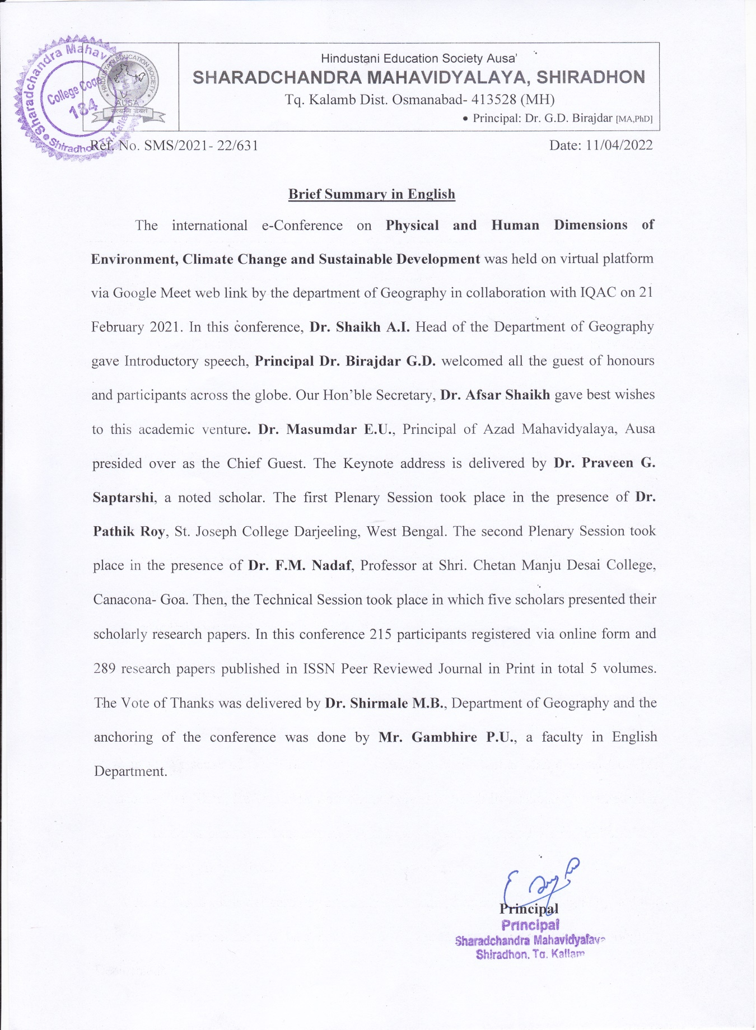

WORK ALLOTMENT OF E-CONFERENCE
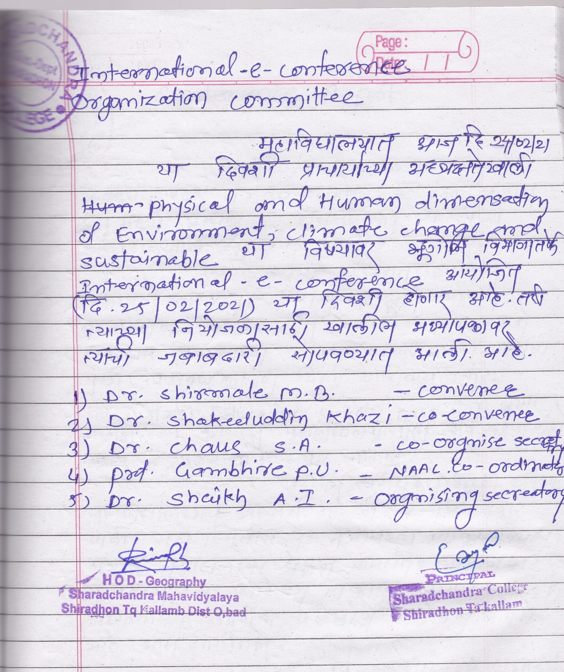

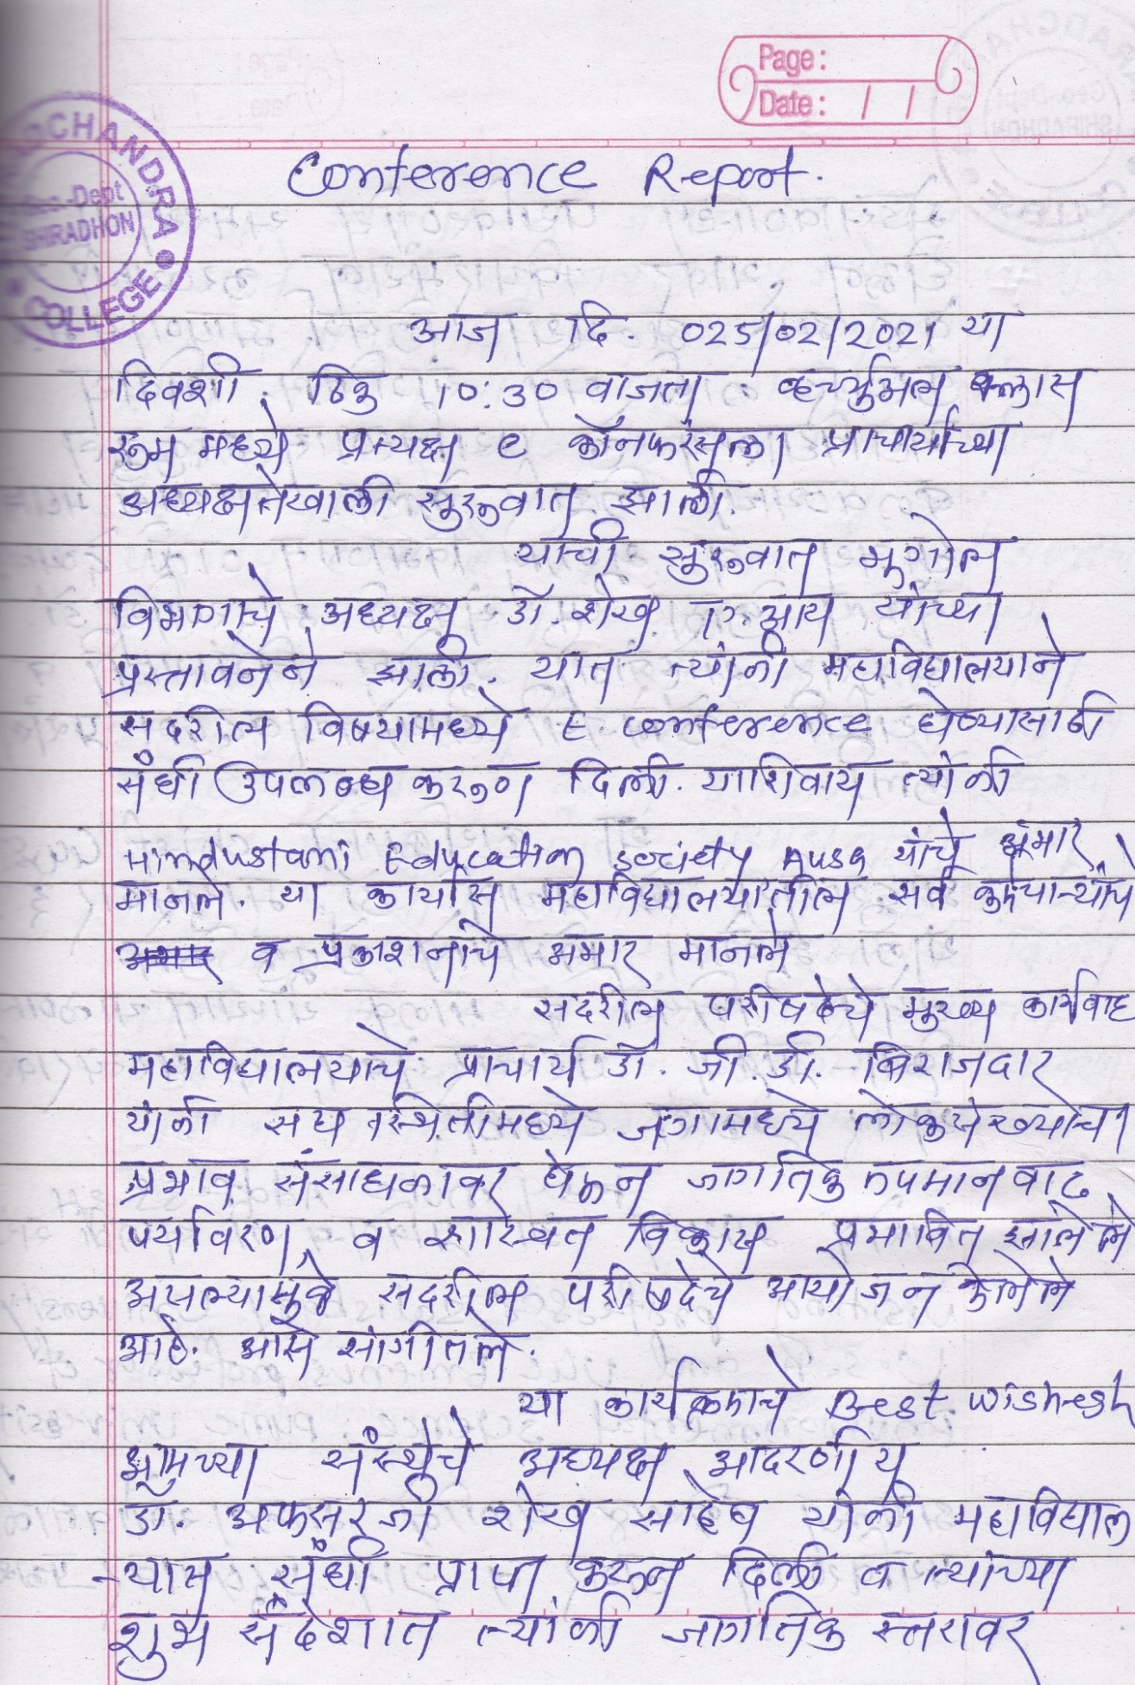
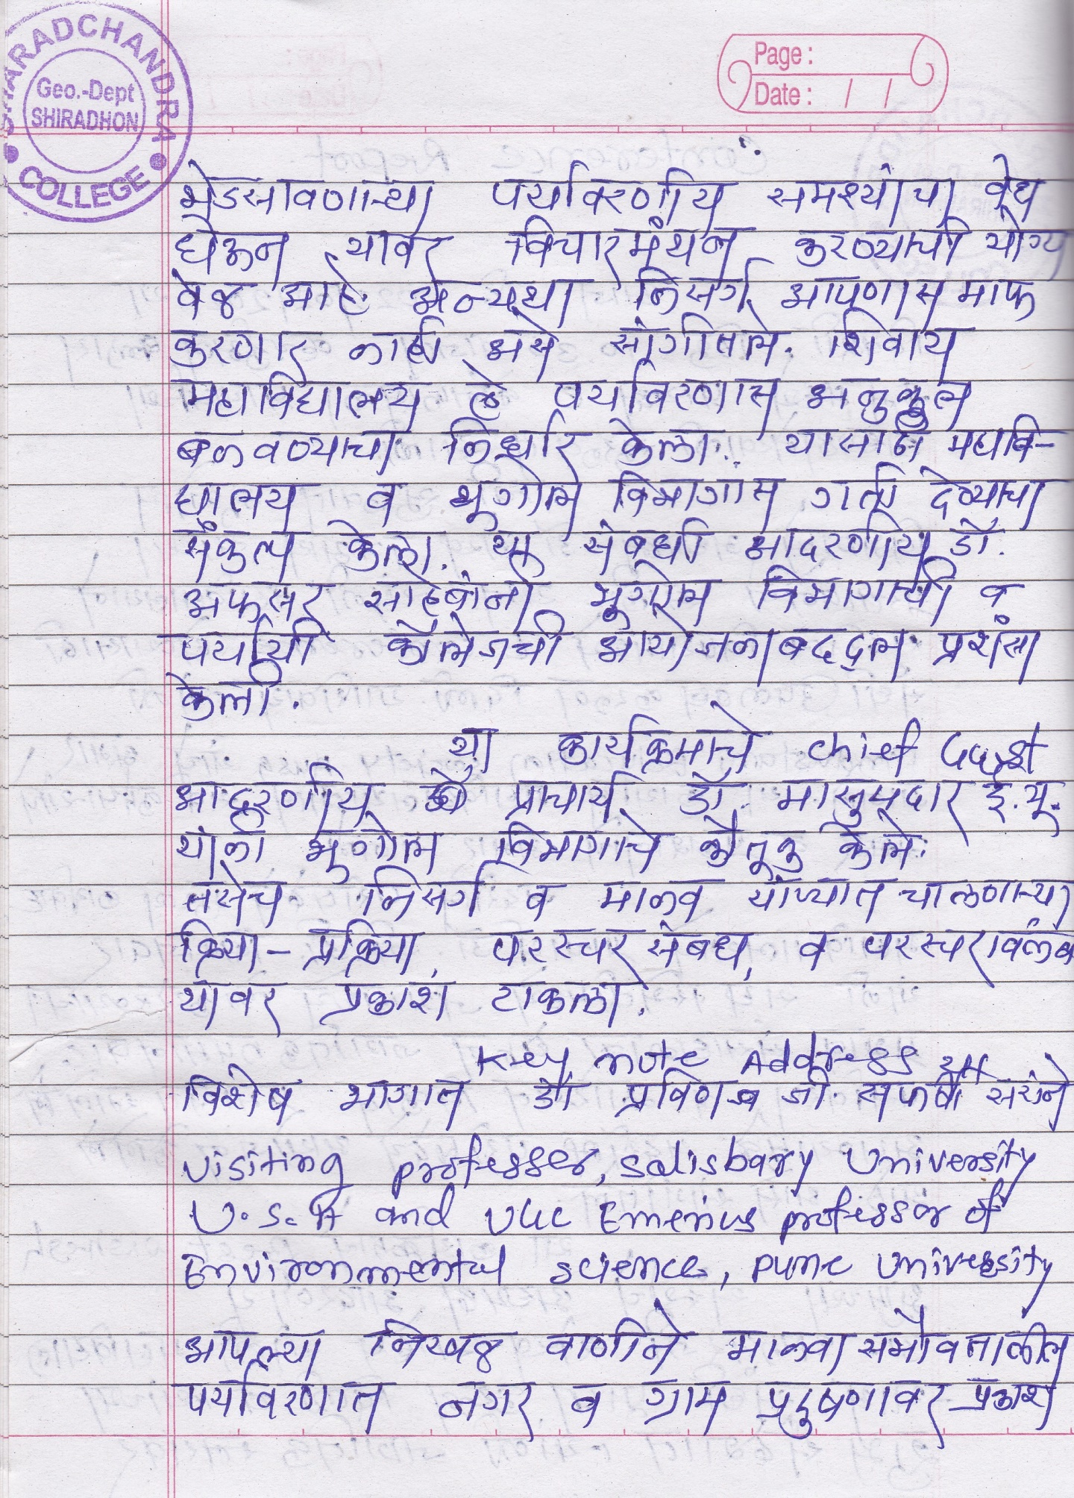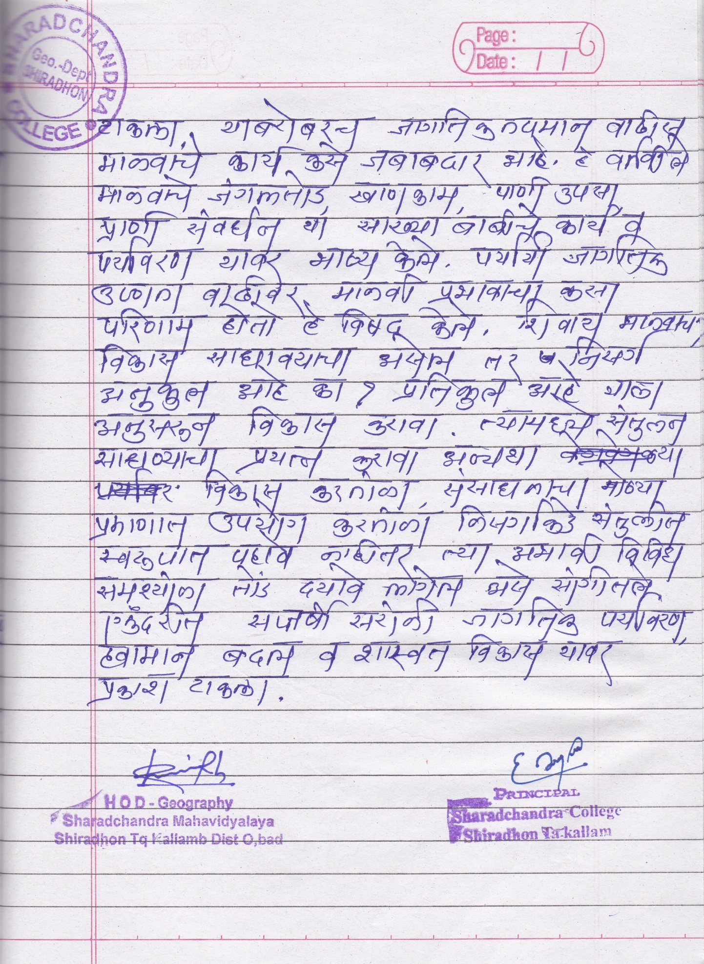

BROCHURE OF E-CONFERENCE
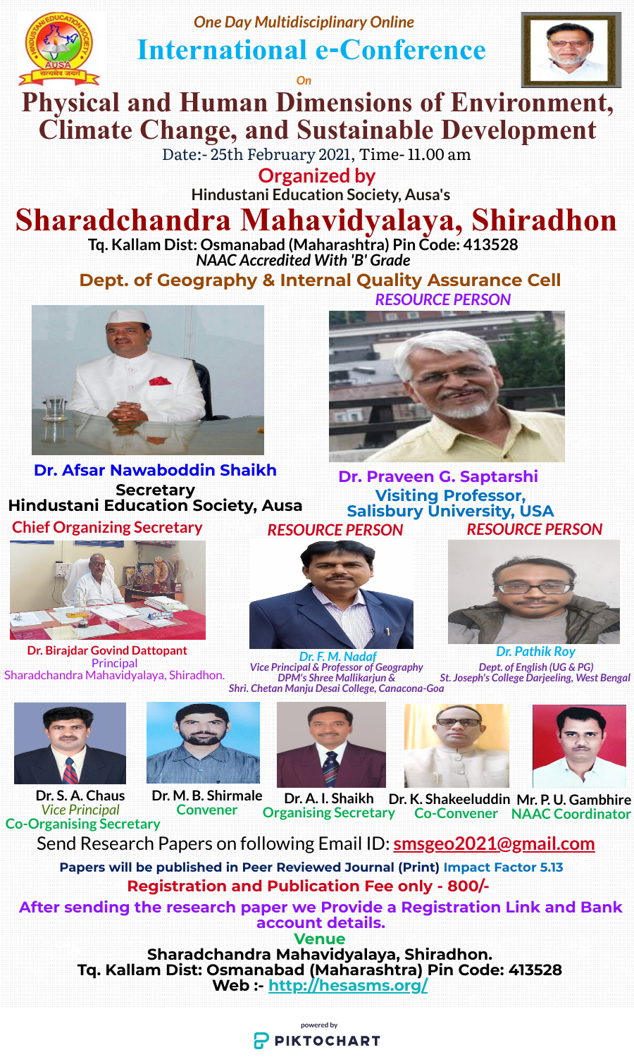

One Day Multidisciplinary Online
International e-Conference
On
Physical and Human Dimensions of Environment, Climate Change and Sustainable Development
Date:- 25th February 2021
Time- 11.00 am
 | 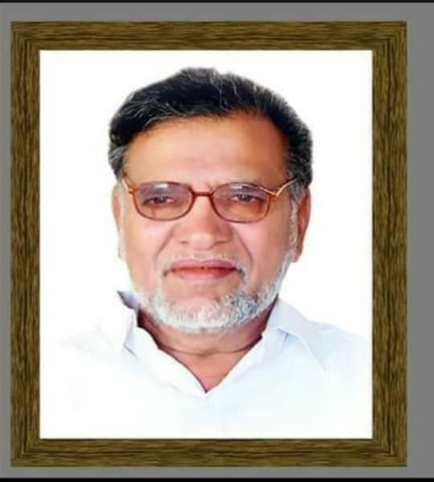 | 
Organized by
Hindustani Education Society, Ausa's

Sharadchandra Mahavidyalaya, Shiradhon
Tq. Kallam Dist: Osmanabad (Maharashtra) Pin Code: 413528
NAAC Accredited With 'B' Grade
Dept. of Geography & Internal Quality Assurance Cell Affiliated to
Dr. Babasaheb Ambedkar Marathwada University, Aurangabad
Chief Organizing Secretary
Dr. Birajdar Govind Dattopant
Principal
Sharadchandra Mahavidyalaya, Shiradhon.
Convener  Dr.M. B. Shirmale.  Dept. Of Geography  Mob.- 9503300948 | Co-Convener  Dr. Shakeeluddin Khazi  IQAC Co-Ordinator  Mob. - 9595785402 | Organising Secretary  Dr. A. I. Shaikh  Head  Dept. Of Geography  Mob-9011418249 | Co-Organising Secretary  Dr. S. A. Chaus  Vice-Principal  Mob.-9422070584
Venue
Sharadchandra Mahavidyalaya, Shiradhon.
Tq. Kallam Dist: Osmanabad (Maharashtra) Pin Code: 413528
Web :- http://hesasms.org/
Papers will be published in Peer Reviewed Journal (Print)
Impact Factor 5.13
Paper Submission last date: 20th February 2021

PATRON
President
Dr. Afsar Nawaboddin Shaikh
Secretary,
Hindustani Education Society, Ausa
RESOURCE PERSONS
Dr. Praveen G. Saptarshi
Visiting Professor, Salisbury University, USA
Professor of Sustainability Management, Indian Institute of Cost and management, Studies & Research (IndSearch), Pune.
UGC Emeritus Professor at Department of Environmental Sciences, Savitribai Phule Pune University
Dr. F. M. Nadaf  Vice Principal &  Professor of Geography  DPM's Shree Mallikarjun & Shri. Chetan Manju Desai College, Canacona-Goa | Dr. Pathik Roy  Dept. of English (UG & PG)  St. Joseph's College Darjeeling, West Bengal
COLLEGE ADVISORY COMMITTEE
Mr. P. U. Gambhire (NAAC Coordinator) |  | Dr. K. G.Gholap | Dr. R. R. Sayyed | Dr. S. M. Alte | Dr. A. F. Sayyed
Dr. S. V Khond | Dr. A. H.Attar | Mr. R. R.Bhise | Mr. Z. A. Khazi | Dr. S. M. Dalve | Dr. F. A. Tamboli
 | Mr. S. P. Adsule | Dr. S. M. Patel | Mrs. S. N. Sayyed

NATIONAL AND INTER NATIONAL ADVISORY COMMITTEE
Dr. Dadasaheb Gajhans Chairman,, BOS,  Dr.BAMU, Aurangabad. | Dr. Manjunath Mankari Chairman, BOS,  SRTMU, Nanded. | Dr. T. N. Lokhande  Chairman,  BOS, AHSU, Solapur. | Dr. K. B. Kankure  Ex. Principal  MUM, Udgir.
Dr. H. B. Rathod  Principal GMV, Kotgyal | Dr. U. B. Pathre  Principal ABM,Devgav Rangari. | Dr. E. U. Masumdar Principal Azad College, Ausa. | Dr. V. S. Anigunte  Principal Arts College, Nadur Ghat.
Dr. N. G. Mali  Principal  Sambhaji College, Murud. | Dr. Sadanand Gone  Principal  Ujwal Gramin College,Ghonsi | Dr. S. D. Shinde  Professor  Head Dept. of Geography and BOS Chairman,  Shivaji University, Kolhapur | Dr. B. M. Bhanje  Principal, SBP College, Mandrup &  Former BCUD Director, Punyashlok Ahilyadevi Holkar Solapur University
Dr. S. A. Patil.  Vice - Principal  ATM, Jalna. | Dr. Madan Suryawanshi HOD,Geo.  Dr. BAMU, Aurangabad. | Dr. Omprakash Shahapurkar Head Dept. of Geography RSM, Latur. | Dr. Sadaf  VKS, University, Bihar.
Dr. V. Govindankutty  Govt. College, Chittur, Kerala. | Dr. H. G. Pisal  Head Dept. of Geography Janvikas College, Bansarola. | Dr. D. G. Ujalambe  Head Dept. of Geography  SJM, Gangakhed. | Dr. N. B. Kadam  Head Dept. of Geography  MPM, Murum.
Dr. N. K. Waghamare  Head Dept. of Geography IGSC, Nanded | Dr. Gajanan Ghodake  Associate Professor  Department of Biological and Environmental Sciences  Dongguk University, Seoul,  South Korea | Neeshi Heeroo-Luximon  Lecturer in Marathi, Mahatma Gandhi Institute,  Marathi Department, School of Indian Studies, Mauritius. | Dr. Sunil Madhukar Gawade  National Petroleum Construction Company,  Abu Dhabi Hydrographic Data Processor
Dr. Anagha Bicholkar  Department of Geography  Chowugle College (Autonomous), Margao-Goa | Dr. Jyotiram More  (Secretary MBP, Pune)  Head, Department of Geography,  B. J. S. College, Wagholi, Pune  Maharashtra State (India) | Suresh Krishna Pawar  Professor in Geography Dept of Geography  Shivaji University Kolhapur Maharashtra India | Dorte Segebart  Freie Universität Berlin  Berlin, Germany  Division of Human Geography  Junior Professorin (Assistant professor)

About College
Sharadchandra Mahavidyalaya, Shiradhon (Arts) is a grant in aid, co-educational minority Status College and affiliated to Dr. Babasaheb Ambedkar Marathwada University, Aurangabad. The college established in June-2001 by Hon’ble Founder President Shri. Shaikh Nawaboddin Bashamiya, to cater the needs of rural student especially to under privileged students from rural, earthquake affected are a sand economically backward classes.
Our college has been constantly attempting not only to provide a mere formal education or just create a graduates but also it has been stressing to inculcate ethical values, values of life, social awareness for arising the feeling of national integration and social consciousness. We all teachers not only offer the victuals of knowledge and intelligence to students but also we offer love, affection and faith to them and we consistently try to uplift them to the door of their highest apex of success and satisfaction. The college aims at the versatile development of the students through the ethical, intellectual, physical and cultural values.
Dear Colleagues,
It gives us an immense pleasure to invite and welcome you to participate in the One Day Multidisciplinary International e-Conference On “Physical and Human Dimensions of Environment, Climate Change and Sustainable Development” organized by Dept. of Geography and Internal Quality Assurance Cell of our College and your esteem presence is cordially solicited.
Global environmental change affects all societies and their environments at various spatial and temporal scales. The linking of natural ecosystems to social ones is of central importance for the analysis, mitigation of and adaptation to any action or issue related to sustainability and global change. When examining the human dimensions of environmental change, the study of ecosystem services illustrates the strong interlink ages existing between both socio-ecological systems and global change. Ecosystem services are inextricably linked to human well-being and play a central role in sustainable adaptation strategies. Environmental impact of global change can both add to social vulnerability and change resilience by altering the supply of ecosystem services and the trade-offs which can occur. It is when examining such phenomena that the importance and abilities of governance systems to shape change and responses are seen. Although many social scientists thus came to study the social determinants and consequences of environmental change, they were even more unprepared to incorporate global changes in the scope of their work. The problems of global warming and the rise in sea levels, in particular, were remote from social science concerns, occurring on temporal and spatial scales which their research paradigms did not contemplate. And unlike environ-mental issues in general, global change did not at first generate socio-political movements which commanded their attention. The early calls for social science involvement came from physical scientists who clearly saw that human activity was responsible for the acceleration of changes observed in world climate. It would be necessary to engage social scientists in these efforts if current trends were to be modified. The challenges of inter and multi-disciplinary research, always stretching the vision – and often the patience – of “normal” scientists, are considerably amplified when collaboration seeks to bridge the gap between natural and social science.
Themes
"Physical and Human Dimensions of Environment, Climate Change and Sustainable Development”
Sub-Themes of Conference
SUB-THEMES |  |  | TARGET AUDIENCE
Physical and Human Dimensions of Environment in Word | Perspectives on climate change and sustainability | A Framework for Research on the Human Dimensions | - Student  - Research Scholars  - Academicians  - Policy Makers & Regulators.  - NGO’s and Registered Society/ Trust  - Geospatial Technologists  - Environmentalists.  - Scientist  - Stakeholder  - All other
Urbanization and Global Environmental Change | climate change, policies, and development. | Biodiversity and ecosystems
Capacity-building | Desertification, land degradation, and drought | Employment, decent work for all and social protection  Energy
Food security and nutrition and sustainable agriculture | Forests | Gender equality and women's empowerment
Health and population | Multi-stakeholder partnerships & voluntary commitments | Sustainable cities and human settlements
Sustainable consumption and production | Violence against children | Water and sanitation
Sustainable tourism | Sustainable transport | Poverty eradication
Rural Development | Chemicals and waste | National Sustainable Development Strategies
Disaster risk reduction | Financial Inclusion | sustainable development is to balance our economic, environmental, and social needs
Industry, Innovation, and Infrastructure | Library Science And Resource Management | Management of Library and Information Centres
Role of Library Science in Human Development | Any Other Sub-Theme Related To Main Theme Of Conference | Any other Subject

DETAILS OF CONFERENCE REGISTRATION
Sr. No. | Indian Delegates |  |  | Foreign Delegates
 | Category | Only Registration | Registration &  Publication Fee (RS) | Category | Registration &  Publication Fee (RS)
1 | Faculty/ Professionals, Research Students & PG/ UG Students | 100/- | 800/- | Faculty/ Professionals, Research Students & PG/ UG Students | Free | Free
Second Author Registration Must Be Compulsory

IMPORTANT NOTE
1 | Date of Conference | 18th march 2021
2 | Paper Submission last date | 15th march 2021
3 | Word Limit | 1600-2000
4 | Page Limit | 4 pages
5 | Email for submitting research papers | smsgeo2021@gmail.com
About Paper Publication:
Authors are invited to submit original papers (not being considered for publication elsewhere) in standard format (that is provided) describing new theoretical and/or experimental research.
Kindly submit your research article/manuscript in .DOC/.DOCX file format to us by mail in English, Hindi, and Marathi at smsgeo2021@gmail.com

Our reviewer team will evaluate the submitted research paper and give notification of research paper Acceptance or rejection.

Only after you receive our E-mail about Acceptance of Paper, you are required to make the necessary payment. Authors will receive hard copy of the Journal by post on the authors’ address.

For English
Full paper should be typed in Microsoft Word. The font should be “Times New Roman” with 12 size for matter,16 size in bold for title, 14 size in bold for main headings & 12 size in bold for sub-headings, having line spacing of 1.5 inch and 1 inch custom margin on all sides & A4 Size Paper.

For Marathi & Hindi
Full paper should be typed in Microsoft Word in "Unicode" with font size- 14 for content, 16 bold for title & 14 bold for headings, having line spacing of 1.5 inch and 1 inch custom margin on all sides.
GUIDELINES FOR RESEARCH PAPER
Empirical | Theoretical
- Bio-data (May be containing Name, Designation Email & Mobile No. of author/authors)  - Abstract  - Introduction  - Rational of the study  - Objectives  - Hypothesis  - Methodology (Containing method, research design, sampling & tool)  - Analysis and data analysis  - Conclusions  - Recommendations  - References | - Bio-data (May be containing name, email & designation  of author/authors)  - Abstract  - Introduction  - Theme or idea  - Conclusions  - References
Important :- 1. Plagiarism upto 28% 2. Citations upto 28%
- For publication related queries Contact: Mr. Santosh Mane (8888454089)
- Papers will be published in Peer-Reviewed Journal (Print), Impact Factor 5.13
Paper Submission last date: 20th February 2021
- REGISTRATION: following link for registration: https://forms.gle/3w1DTCaLqCnenQuP6
(After sending the research paper we Provide any other Google Form link for Publication and Bank account details.)
- After registration follow this link to join
1. Telegram Group: https://t.me/InternationalConf25thFebruary
- After registration follow this link to join WhatsApp Group
- Inter e-conf. WhatsApp Group - 1 https://chat.whatsapp.com/HnnqT7C5tksGA98K3HFYYf
- Inter e-conf. WhatsApp Group - 2 https://chat.whatsapp.com/FE56kLSDK0EBYrhDSjm1qr
Send Research Papers on following Email ID: smsgeo2021@gmail.com

SCHEDULE OF E-CONFERENCE

Hindustani Education Society, Ausa's

Sharadchandra Mahavidyalaya, Shiradhon
Tq. Kallam Dist: Osmanabad (Maharashtra) Pin Code: 413528
NAAC Accredited With 'B' Grade
One Day Multidisciplinary Online
International e-Conference
On
Physical and Human Dimensions of Environment, Climate Change and Sustainable Development
Date:- 25th February 2021, Time- 11.00 am


All the participant join the Google meet on dated :- 25th February 2021.


Join 10.40 am (IST)
To join the video meeting, click this link

meet.google.com/ucf-ftgj-rja

INTRODUCTORY SPEECH
Organising Secretary
Dr. A. I. Shaikh
Head , Dept. Of Geography

Time- 11.00am to 11.05 am

WELCOME SPEECH
Chief Organizing Secretary
Dr. Birajdar Govind Dattopant
Principal

Sharadchandra Mahavidyalaya, Shiradhon

Time- 11.05 am to 11.10 am

BEST WISHES
Dr. Afsar Nawaboddin Shaikh
Secretary

Hindustani Education Society, Ausa

Time- 11.10 am to 11.15 am

CHIEF GUEST SPEECH
Dr. Masumdar E. U.
Principal

Azad College, Ausa

Time- 11.15 am to 11.20 am

KEY NOTE ADDRESS
Dr. Praveen G. Saptarshi
Visiting Professor, Salisbury University, USA
Professor of Sustainability Management, Indian Institute of Cost and management, Studies & Research (IndSearch), Pune.
UGC Emeritus Professor at Department of Environmental Sciences, Savitribai Phule Pune University
Subject- Key Note Address
Time-11.20 to 12.00 pm
Chairman
Dr. Dadasaheb Gajhans
Chairman,, BOS,

Dr.BAMU, Aurangabad.

PLENARY SESSION –I
Dr. Pathik Roy
Dept. of English (UG & PG)
St. Joseph's College Darjeeling, West Bengal
Topic: Anthropocene and the Failure of Imagination Revisiting Amitav Ghosh's The Great Derangement of Climate Change and The Unthinkable
Time- 12.05 pm to 12.45 pm

Chairman
Dr. S. A. Chaus
Vice-Principal

Sharadchandra Mahavidyalaya, Shiradhon

PLENARY SESSION –II
Dr. F. M. Nadaf
Vice Principal & Professor of Geography
DPM's Shree Mallikarjun & Shri. Chetan Manju Desai College, Canacona-Goa
Topic: Human Modifications of Coastal Areas
Time- 12.45 pm to 01.25 pm
Chairman
Dr. Manjunath Mankari
Chairman, BOS, SRTMU, Nanded.

TECHNICAL SESSION-I

Paper Presentation

Time- 01.25 pm to 01.55 pm
Chairman

Dr. Omprakash Shahapurkar

Head Dept. of Geography RSM, Latur.

&
Dr. N. K. Waghamare

Head Dept. of Geography IGSC, Nanded

Vote of Thanks
Convener
Dr.M. B. Shirmale.

Dept. Of Geography

Sharadchandra Mahavidyalaya, Shiradhon

Jana Gana Mana (HD) - National Anthem

https://www.youtube.com/watch?v=HtMF973tXIY

Feedback Form- https://forms.gle/paFLpsPxkR3KTWoSA

Chief Organizing Secretary
Dr. Birajdar Govind Dattopant
Principal
Sharadchandra Mahavidyalaya, Shiradhon.
Convener  Dr.M. B. Shirmale.  Dept. Of Geography  Mob.- 9503300948 | Co-Convener  Dr. Shakeeluddin Khazi  IQAC Co-Ordinator  Mob. - 9595785402 | Organising Secretary  Dr. A. I. Shaikh  Head  Dept. Of Geography  Mob-9011418249 | Co-Organising Secretary  Dr. S. A. Chaus  Vice-Principal  Mob.-9422070584

SCHEDULE ON WHATSAPP GROUP & TELEGRAM CHANNEL
Please Join the Telegram Group For Future Instructions
https://t.me/InternationalConf25thFebruary

FINAL SCHEDULED

Hindustani Education Society, Ausa's
Sharadchandra Mahavidyalaya, Shiradhon
Tq. Kallam Dist: Osmanabad (Maharashtra) Pin Code: 413528
NAAC Accredited With 'B' Grade
One Day Multidisciplinary Online
International e-Conference
On
Physical and Human Dimensions of Environment, Climate Change, and Sustainable Development
Date:- 25th February 2021, Time- 11.00 am
All the Participant join the Google meet on dated:- 25th February 2021.

Join 10.40 am (IST)
To join the video meeting, click this link
meet.google.com/ucf-ftgj-rja

INTRODUCTORY SPEECH
Organising Secretary
Dr. A. I. Shaikh
Head, Dept. Of Geography
Time- 11.00am to 11.05 am

WELCOME SPEECH
Chief Organizing Secretary
Dr. Birajdar Govind Dattopant
Principal
Sharadchandra Mahavidyalaya, Shiradhon
Time- 11.05 am to 11.10 am

BEST WISHES
Dr. Afsar Nawaboddin Shaikh
Secretary
Hindustani Education Society, Ausa
Time- 11.10 am to 11.15 am

CHIEF GUEST SPEECH
Dr. Masumdar E. U.
Principal
Azad College, Ausa
Time- 11.15 am to 11.20 am

KEY NOTE ADDRESS
Dr. Praveen G. Saptarshi
Visiting Professor, Salisbury University, USA
Professor of Sustainability Management, Indian Institute of Cost and management, Studies & Research (IndSearch), Pune.
UGC Emeritus Professor at Department of Environmental Sciences, Savitribai Phule Pune University
Subject- Key Note Address
Time-11.20 to 12.00 pm
Chairman
Dr. Dadasaheb Gajhans
Chairman,, BOS,
Dr.BAMU, Aurangabad.

PLENARY SESSION –I
Dr. Pathik Roy
Dept. of English (UG & PG)
St. Joseph's College Darjeeling, West Bengal
Topic: Anthropocene and the Failure of Imagination Revisiting Amitav Ghosh's The Great Derangement of Climate Change and The Unthinkable
Time- 12.05 pm to 12.45 pm

Chairman
Dr. S. A. Chaus
Vice-Principal
Sharadchandra Mahavidyalaya, Shiradhon

PLENARY SESSION –II
Dr. F. M. Nadaf
Vice Principal & Professor of Geography
DPM's Shree Mallikarjun & Shri. Chetan Manju Desai College, Canacona-Goa
Topic: Human Modifications of Coastal Areas
Time- 12.45 pm to 01.25 pm
Chairman
Dr. Manjunath Mankari
Chairman, BOS, SRTMU, Nanded.

TECHNICAL SESSION-I
Paper Presentation
Time- 01.25 pm to 01.55 pm
Chairman
Dr. Omprakash Shahapurkar
Head Dept. of Geography RSM, Latur.
&
Dr. N. K. Waghamare
Head Dept. of Geography IGSC, Nanded

Vote of Thanks
Convener
Dr.M. B. Shirmale.
Dept. Of Geography
Sharadchandra Mahavidyalaya, Shiradhon

Jana Gana Mana (HD) - National Anthem
https://www.youtube.com/watch?v=HtMF973tXIY

GLIMPSES OF E-CONFERENCE
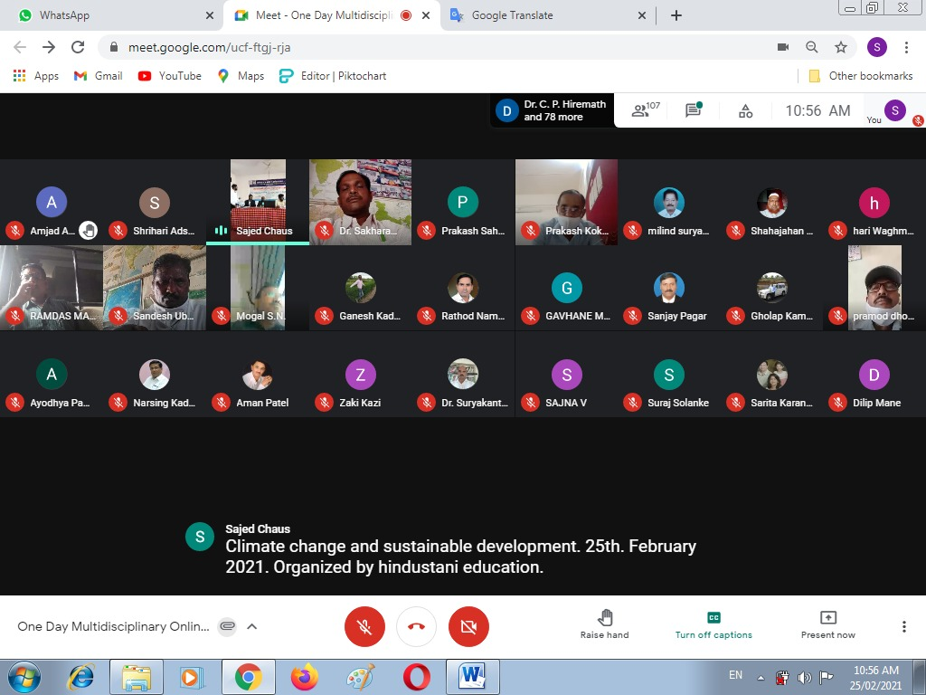

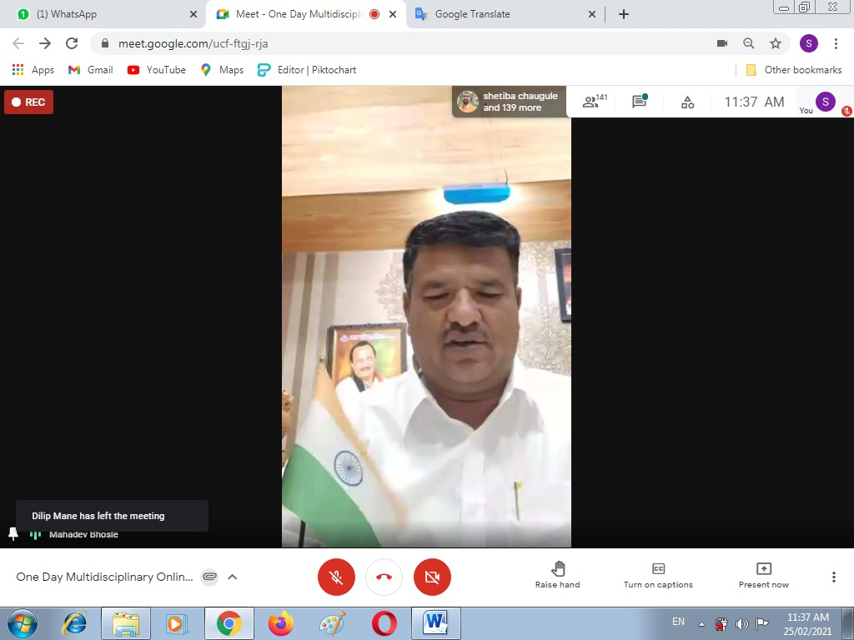
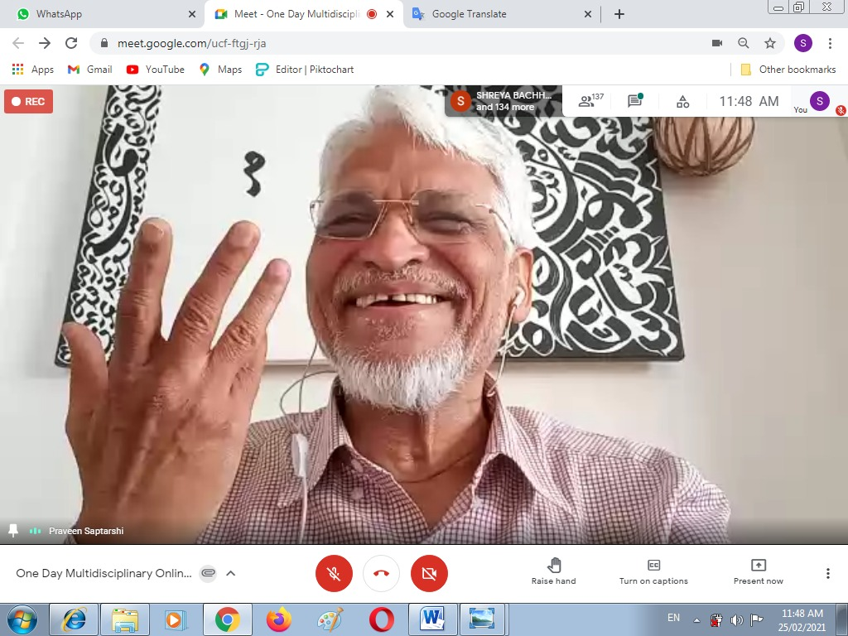

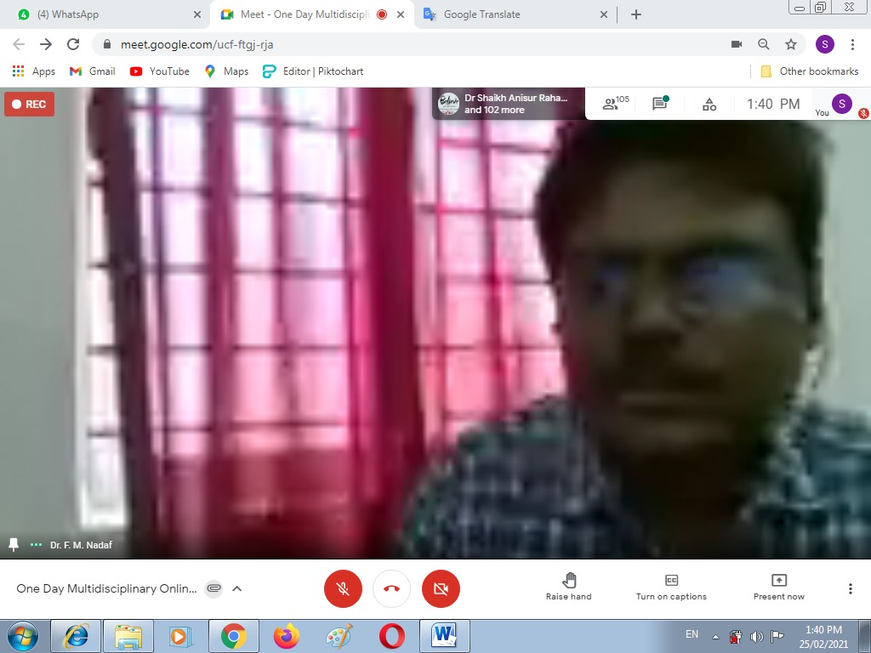
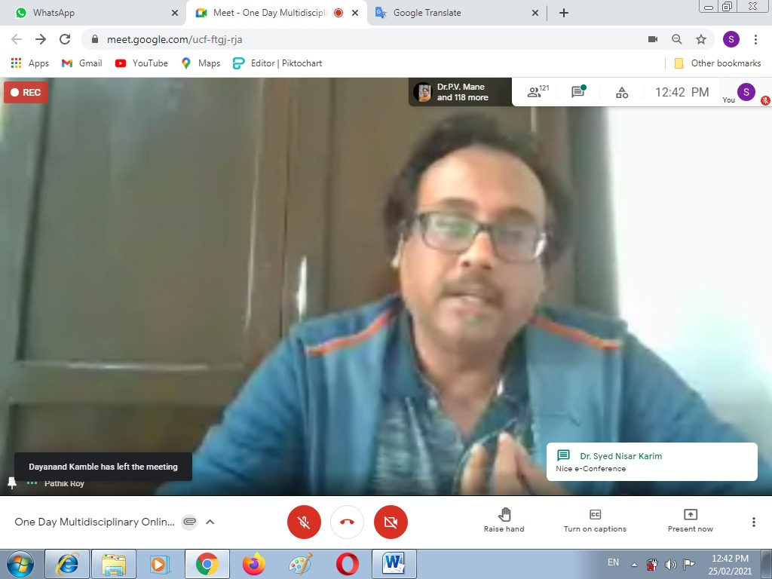
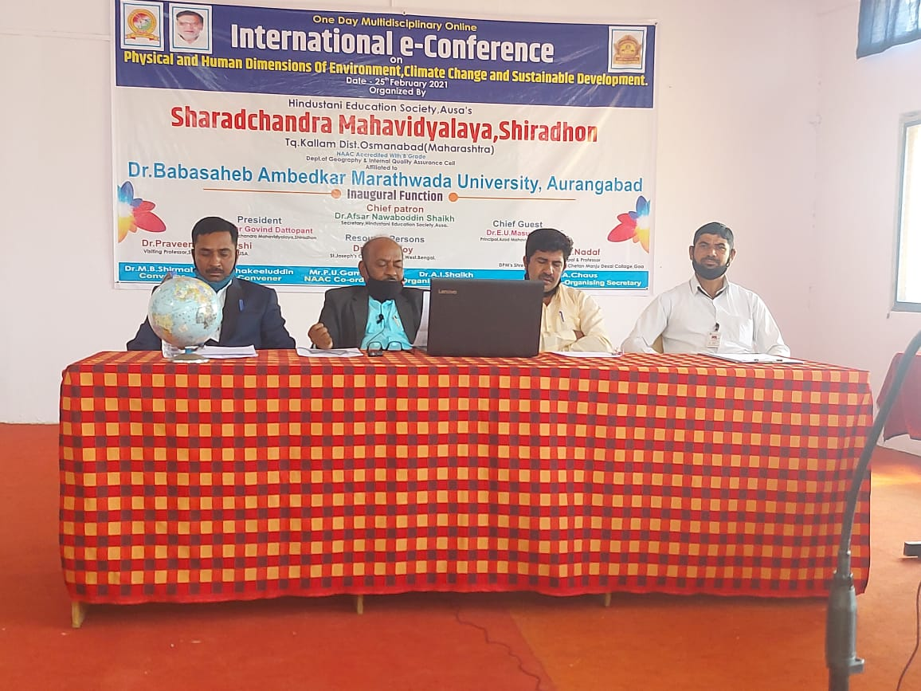
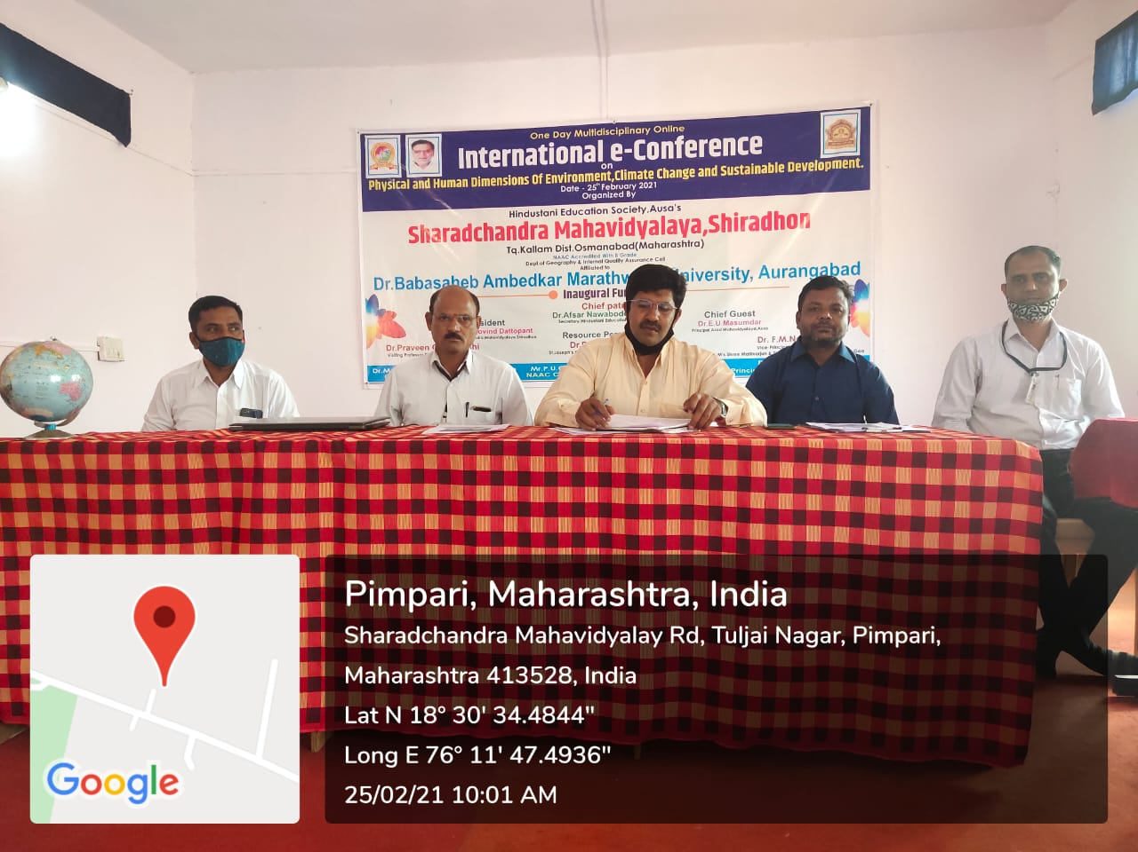
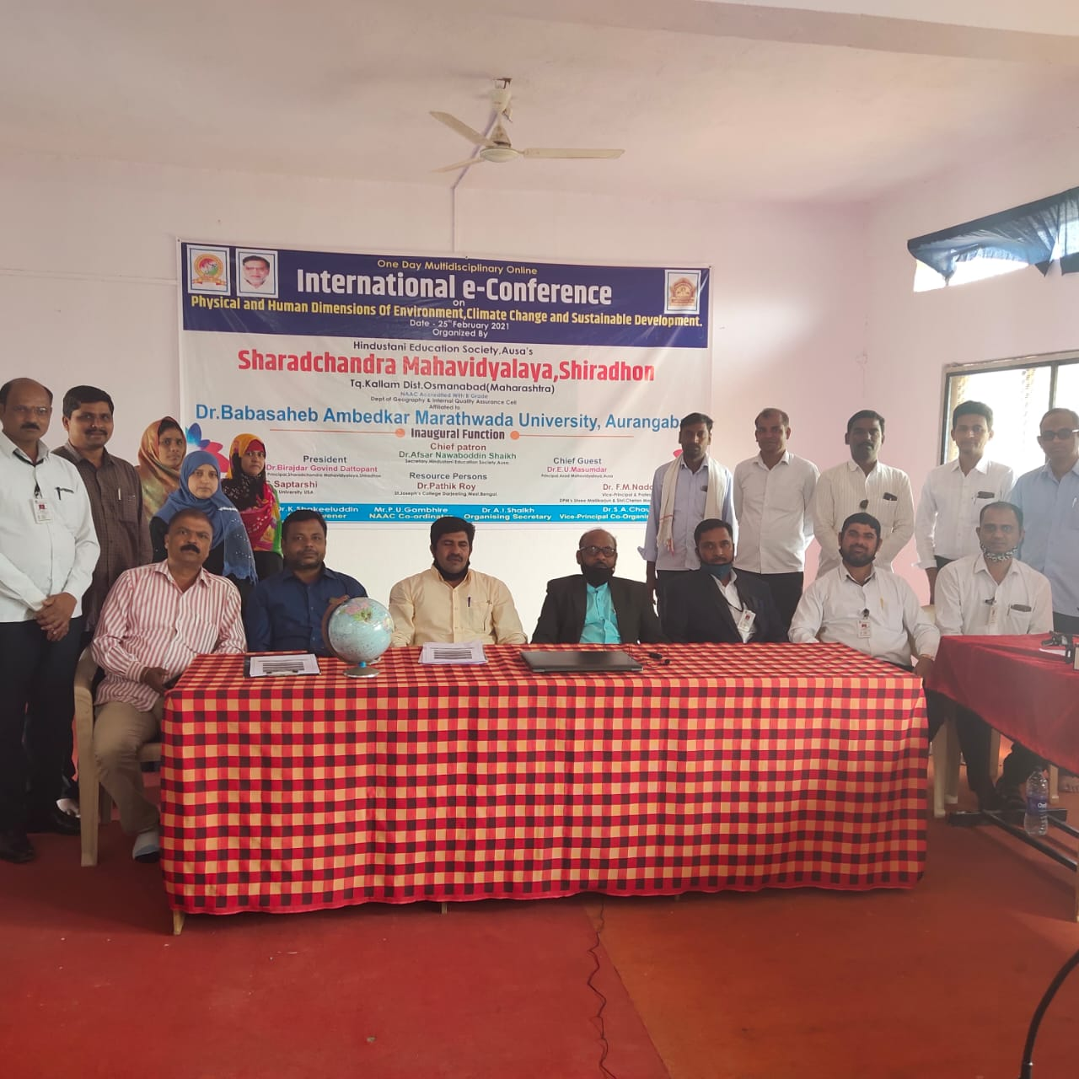

FEEDBACK
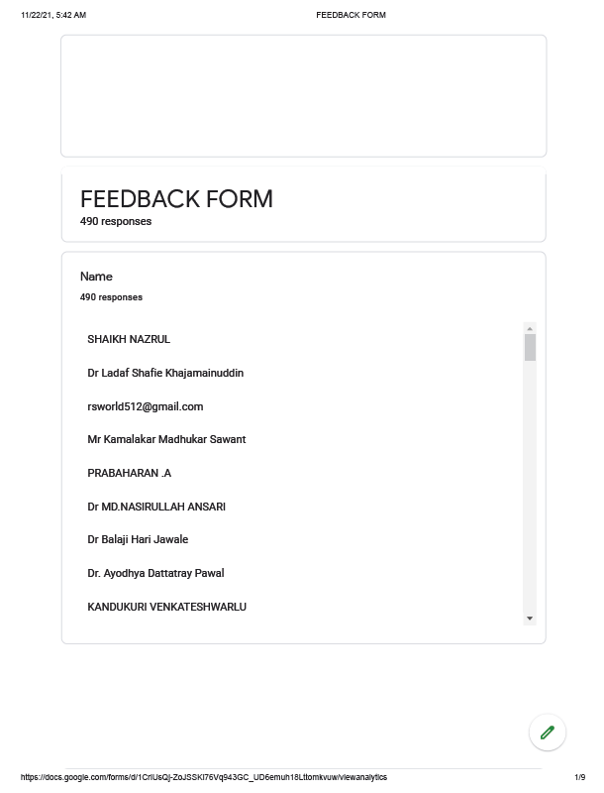

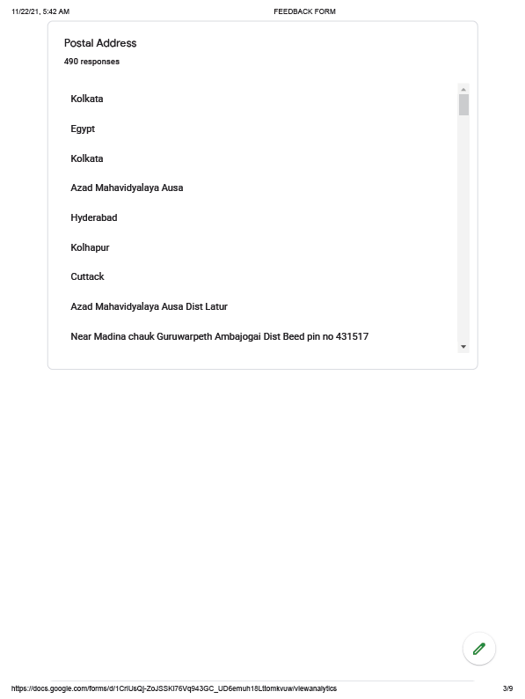
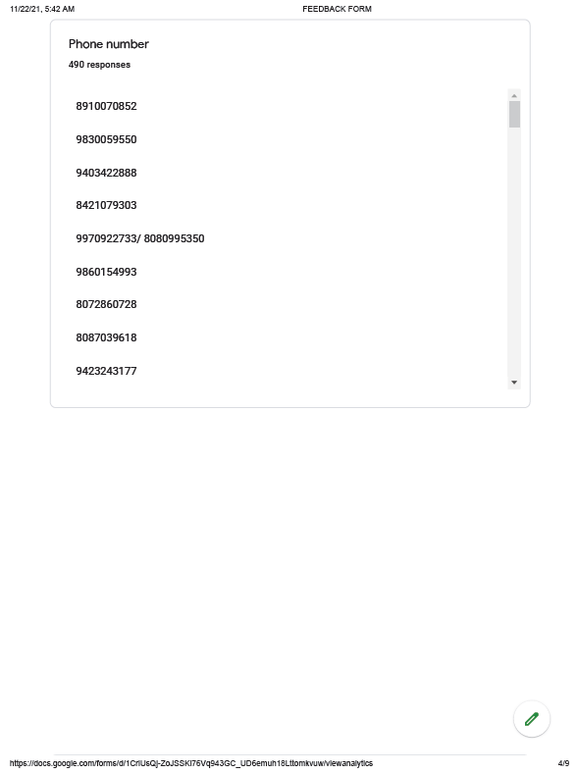
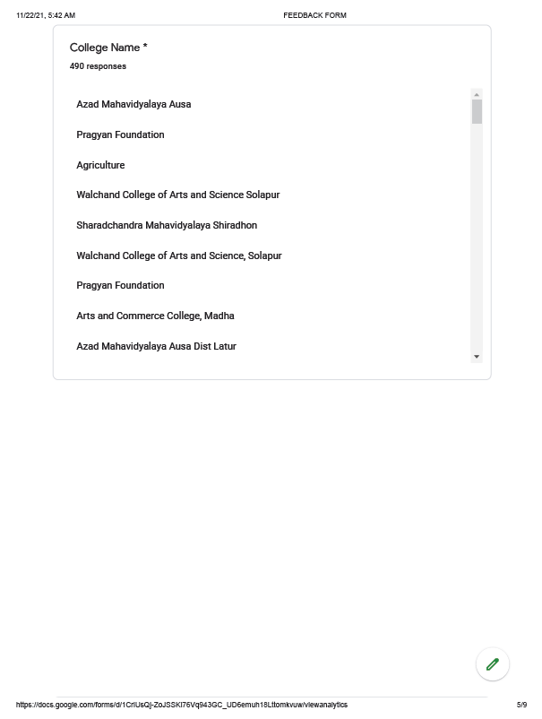

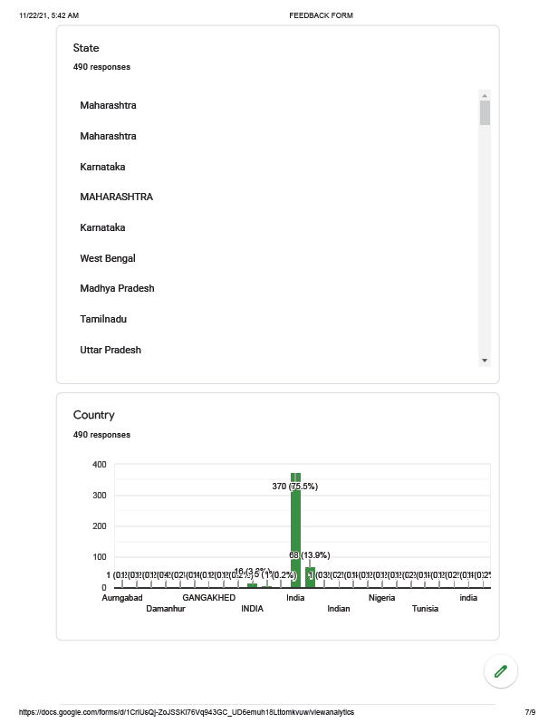
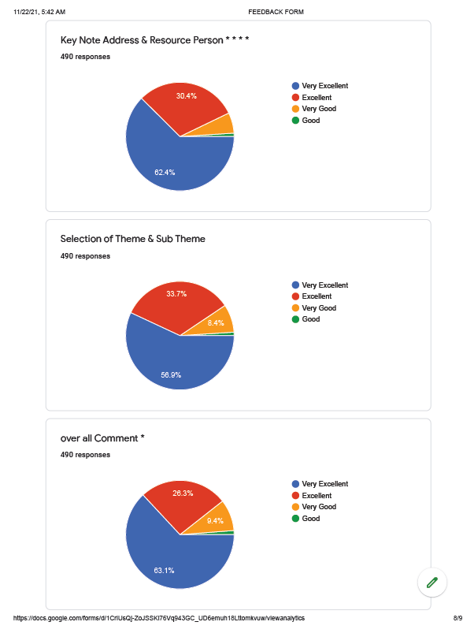

THANK YOU !

